SOSÚA
A Haven of Hope
The Visual Story of the Musical

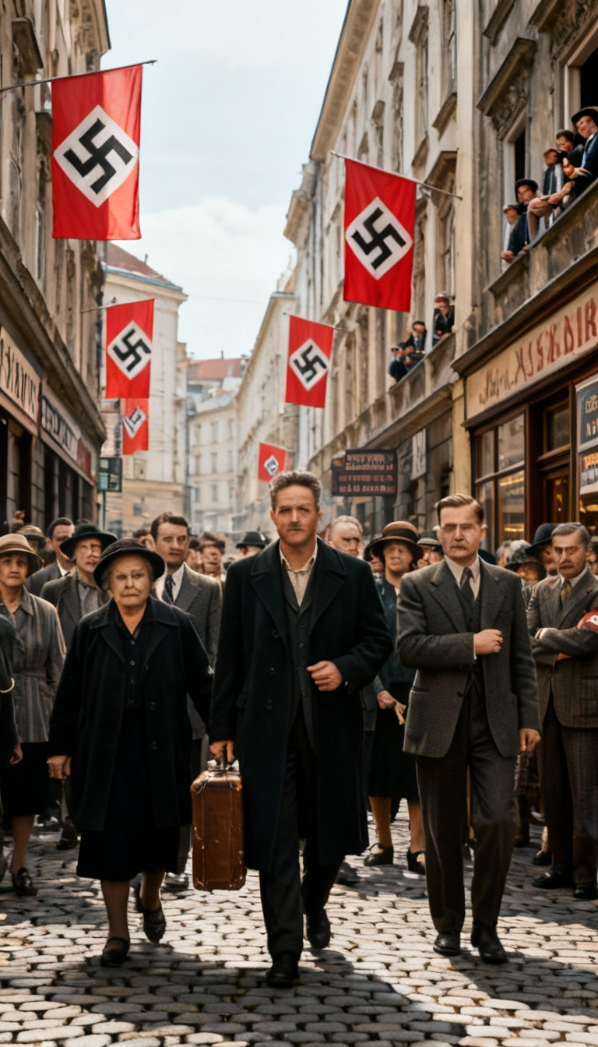
Vienna, 1938. Josef walks through Nazi-occupied streets, saying goodbye to everything he knows.

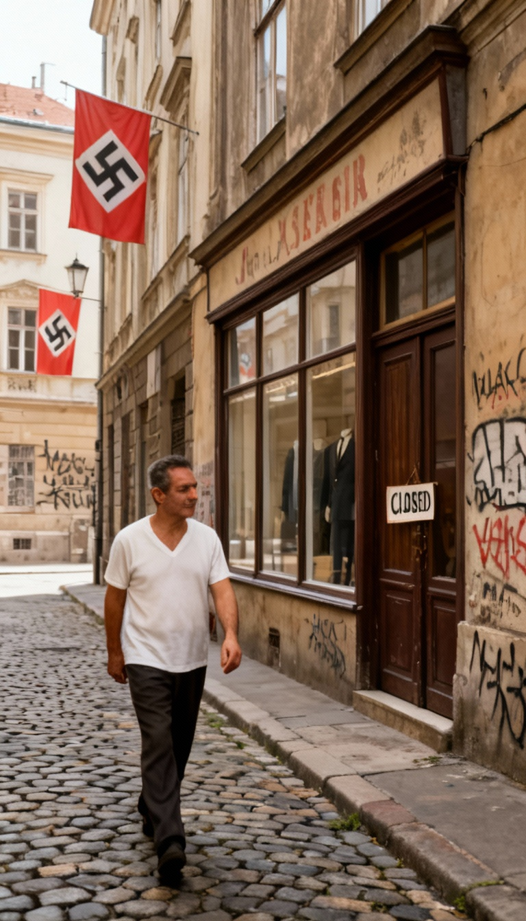
"Farewell, Austria" - Josef's tailor shop, closed and vandalized. Nazi flags everywhere.

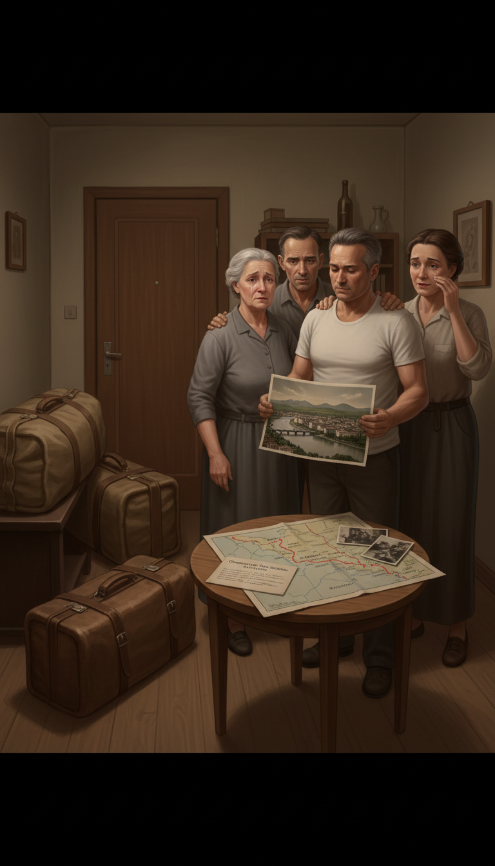
Josef's family gathers around maps, photographs, and DORSA documents - planning their escape.

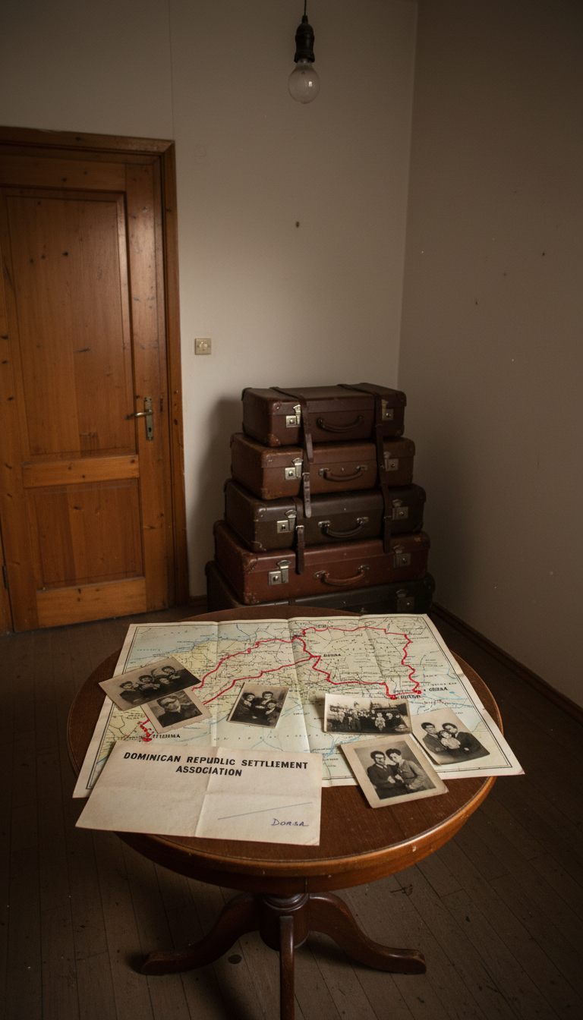
Suitcases packed. The map to Dominican Republic. Family photos. The moment before departure.

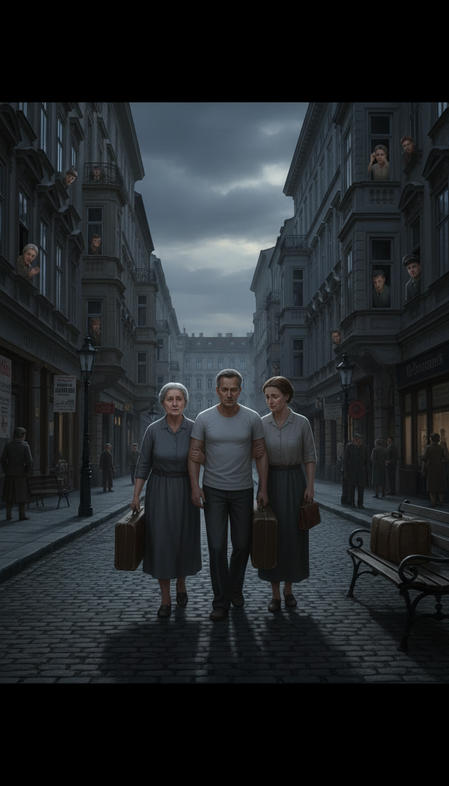
The final goodbye - Josef with family members in the dark Vienna streets.

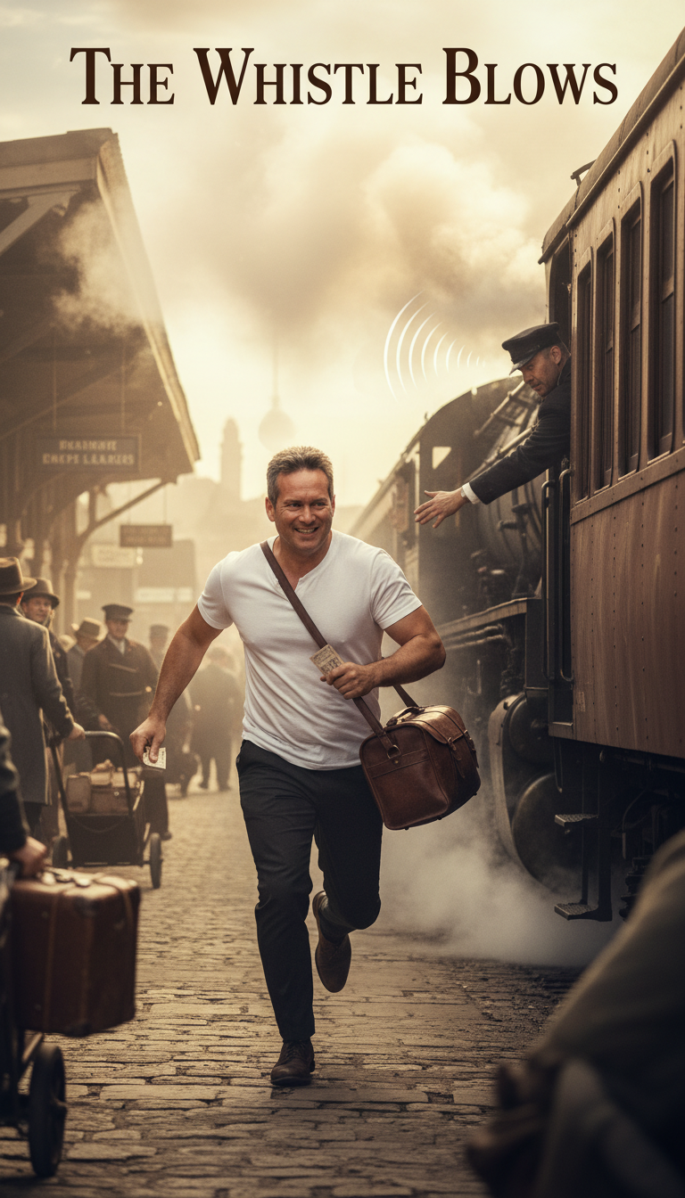
A refugee family with their few possessions, beginning the journey to freedom.

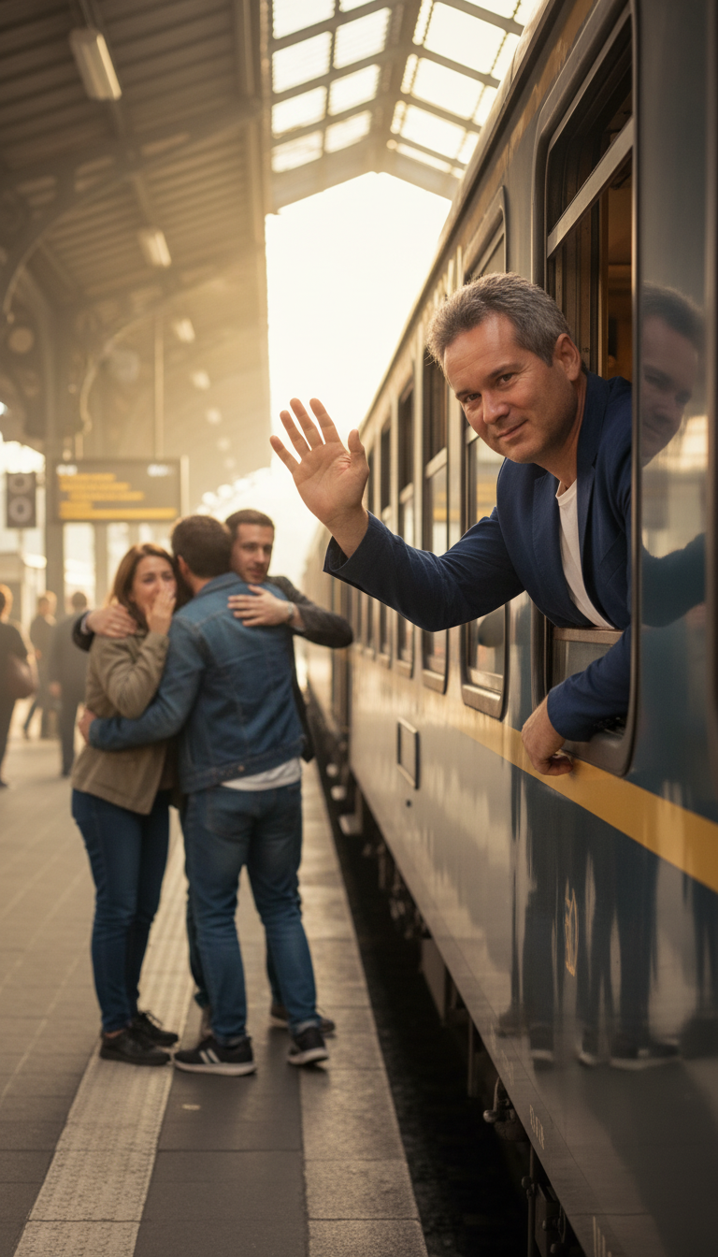
Jewish refugees aboard ship, leaving Europe behind for an uncertain future.

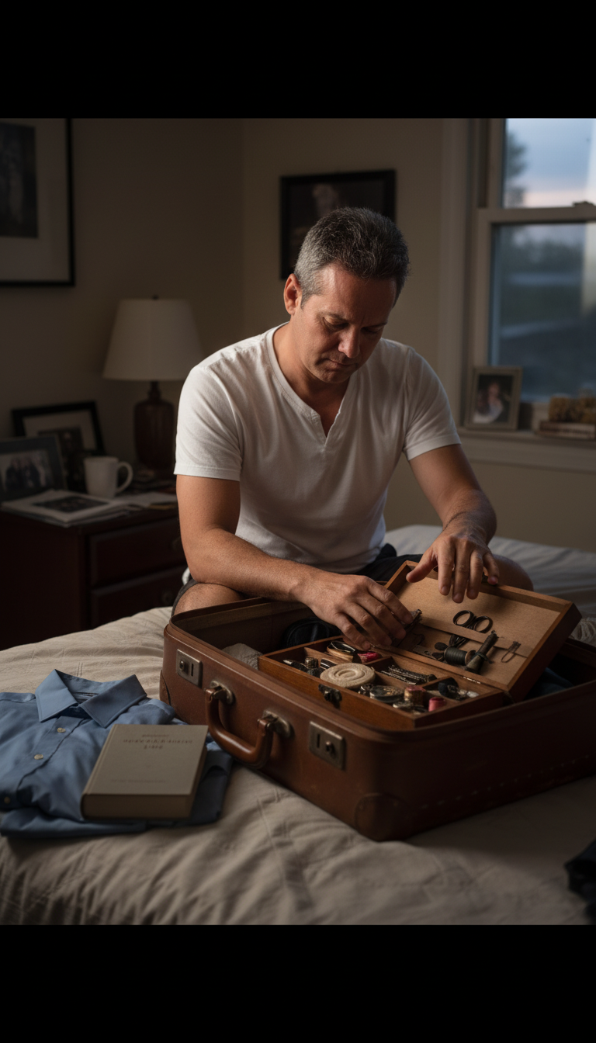
Josef's sewing tools and tailor's kit - his skills that would help him rebuild.

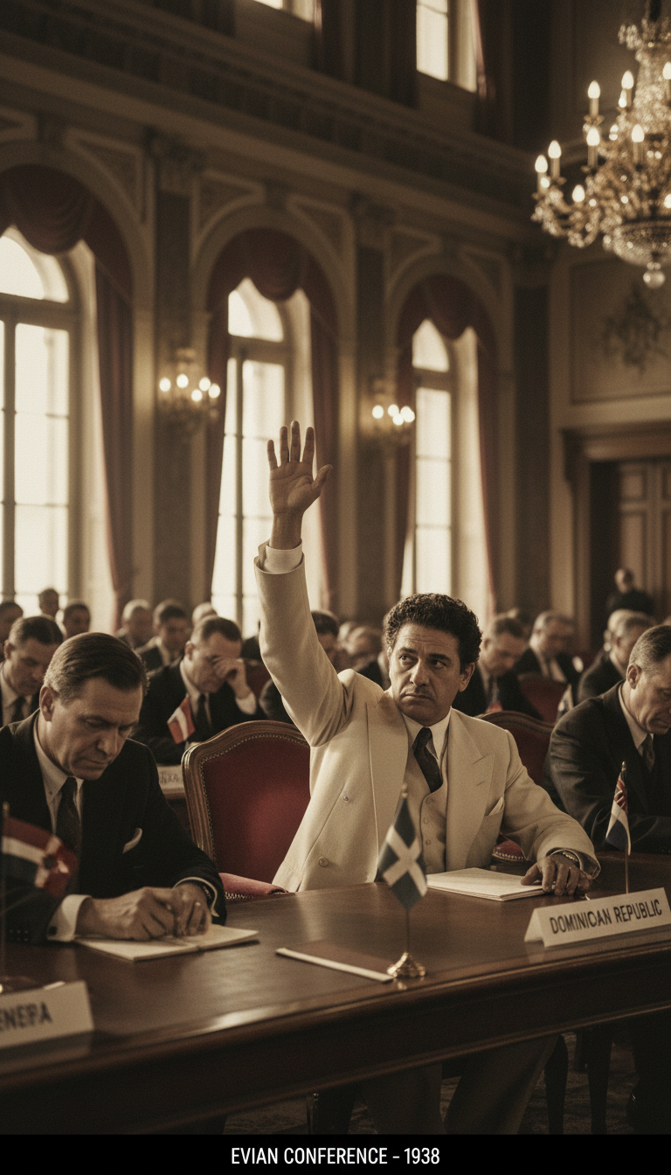
"Echoes of Tomorrow" - Évian Conference, 1938. The Dominican delegate raises his hand - the only nation to say YES.

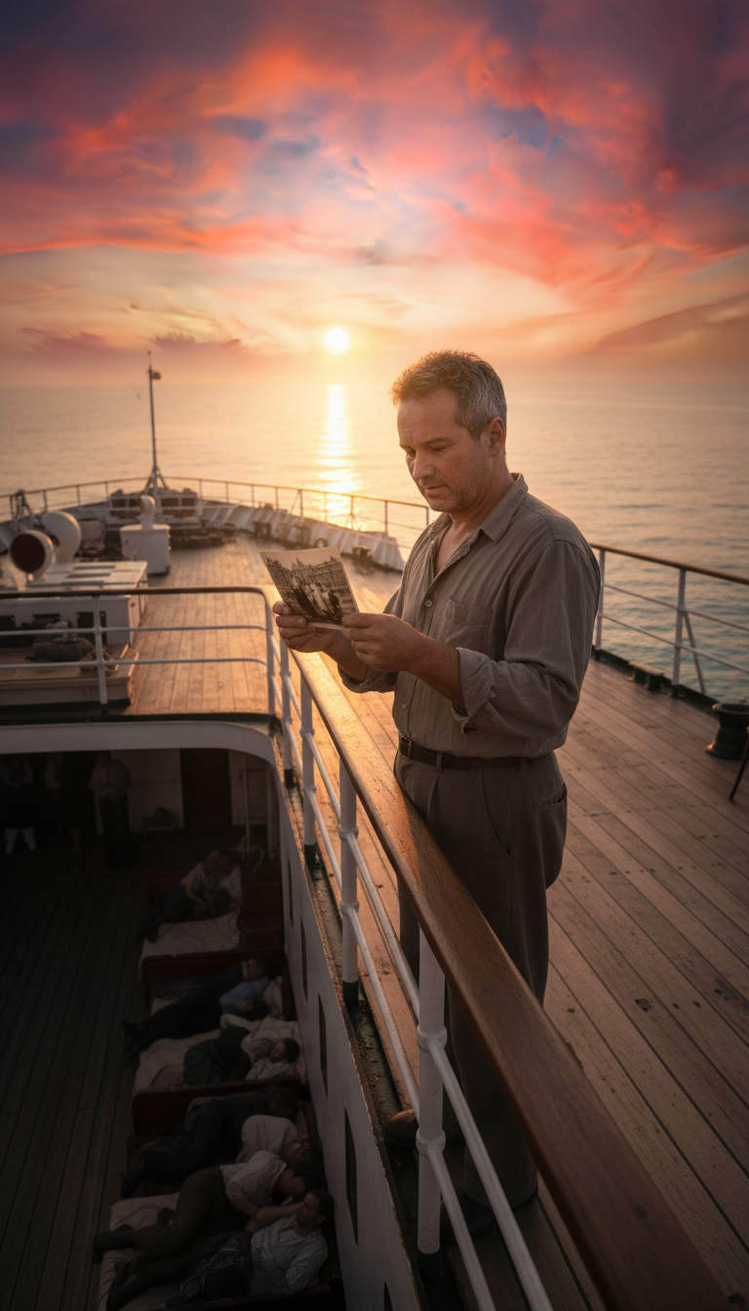
"Josef on His Voyage" - Reading letters, watching the sunset, sailing toward Sosúa.

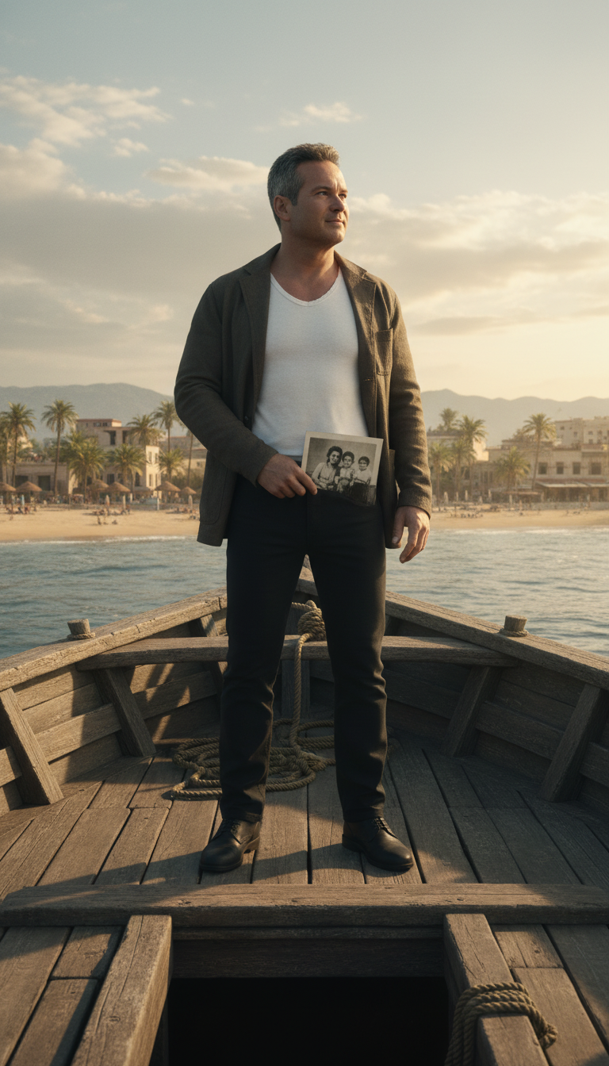
Arriving in Sosúa - Josef holds a photograph of his family as he looks toward his new home.

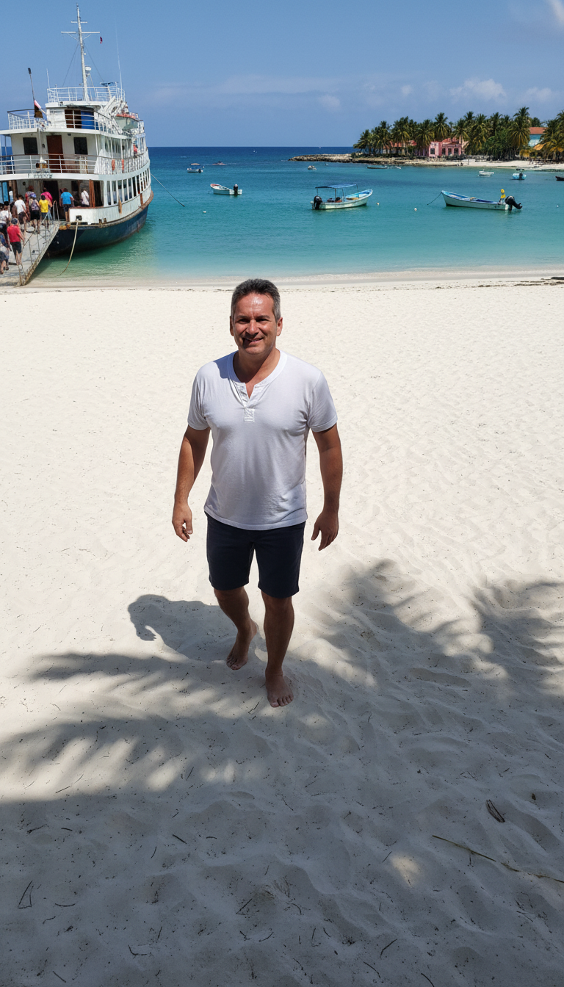
The turquoise waters and pristine beaches of Sosúa - a world away from Vienna.

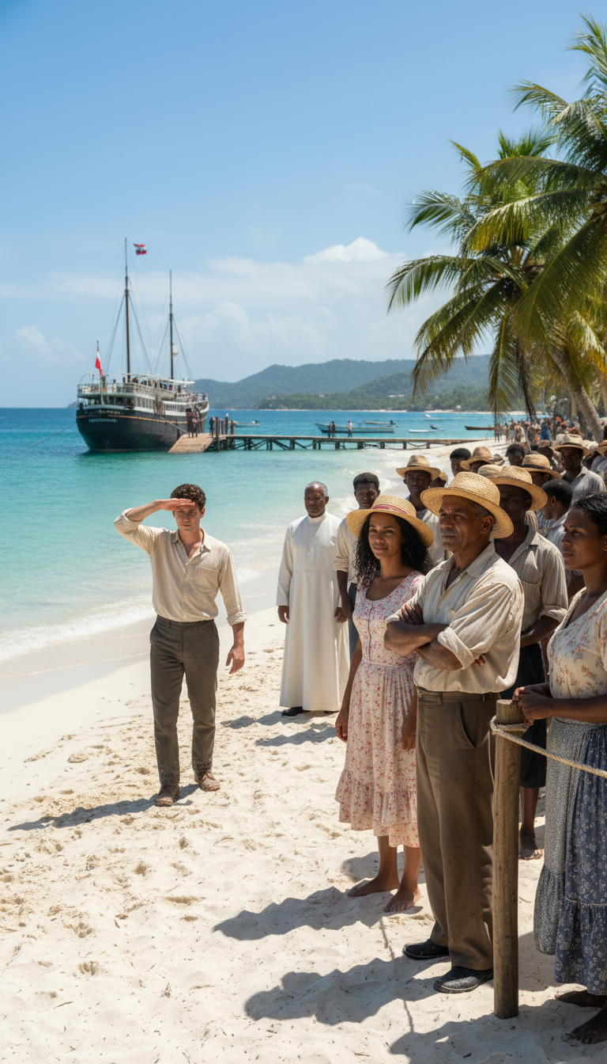
"Strangers on the Shore" - Dominican community gathered on the beach to meet the refugees.

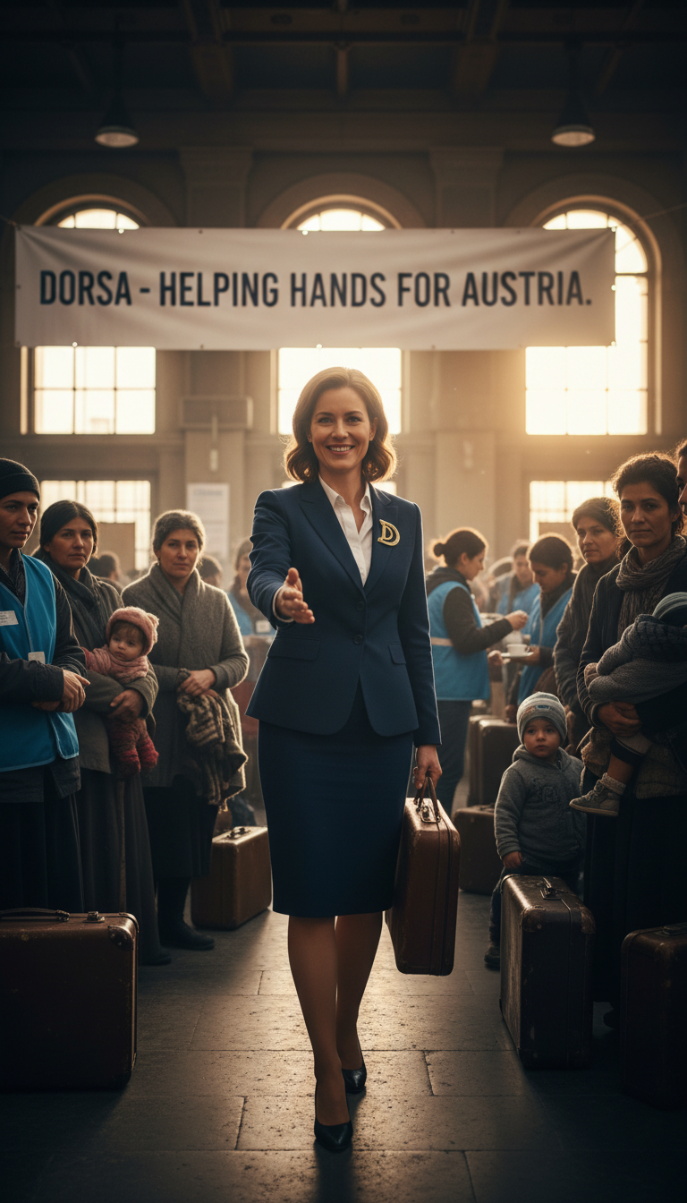
DORSA representative welcoming refugees - offering hope and a helping hand.

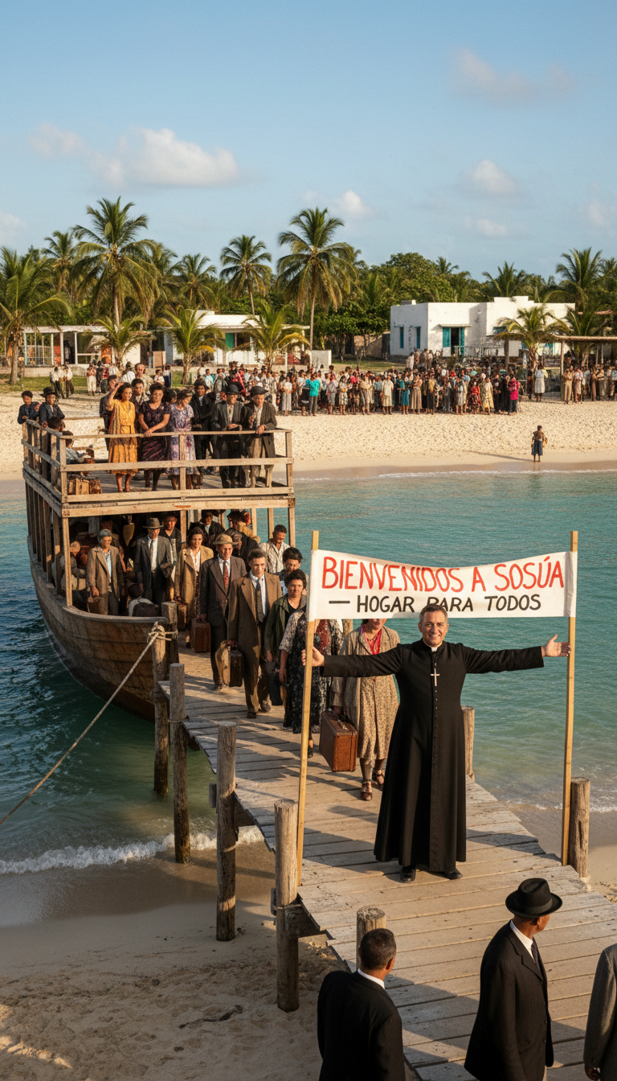
Padre Luis with sign: 'BIENVENIDOS A SOSÚA - HOGAR PARA TODOS' - Welcome Home.

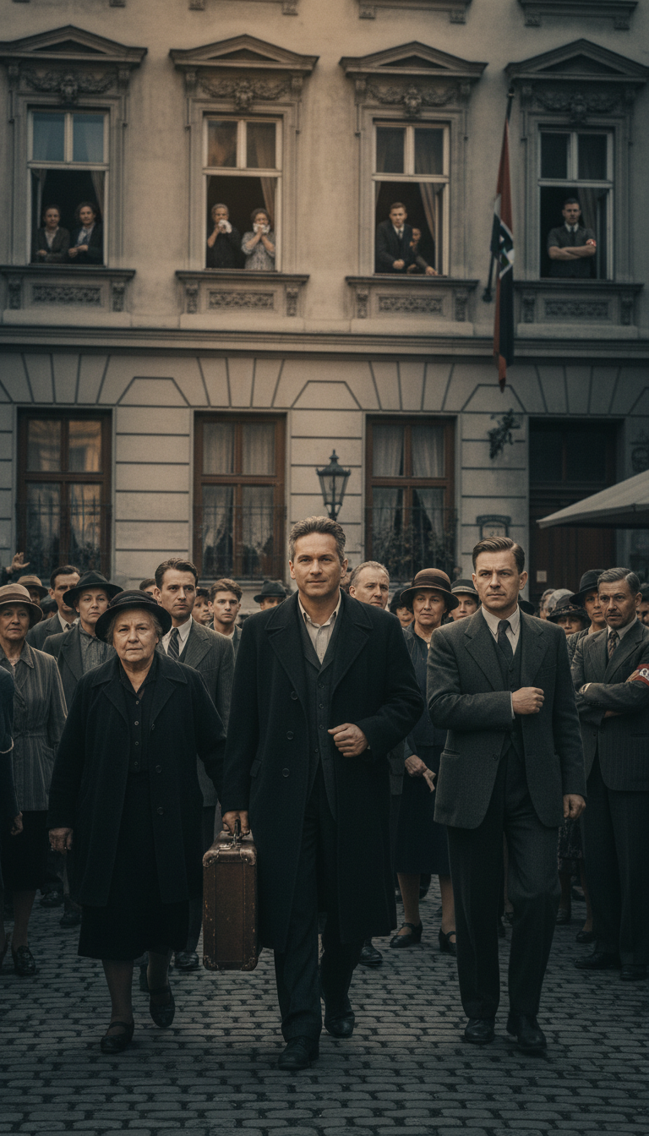
Early refugees arriving, carrying hope and uncertainty.

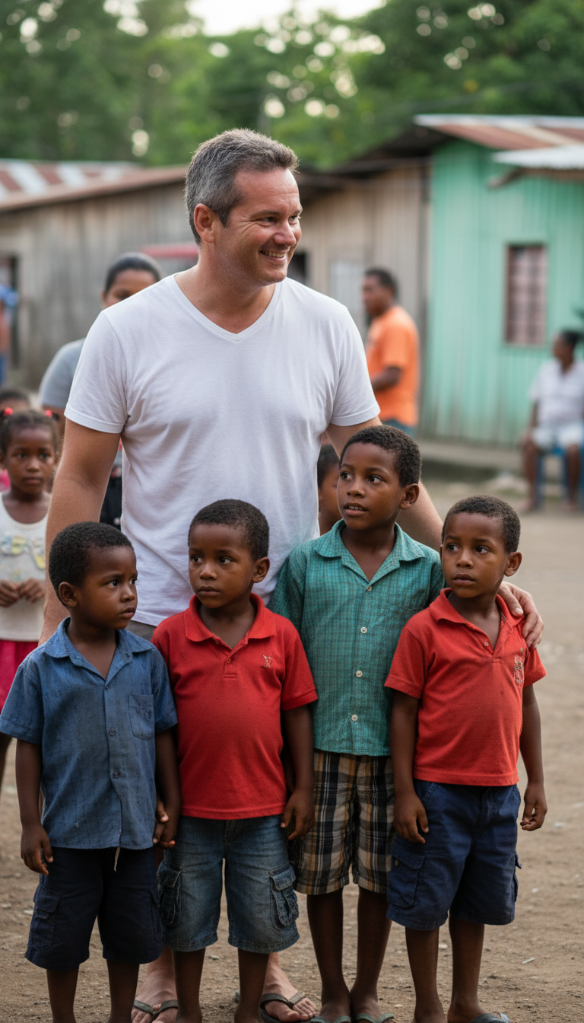
Dominican children welcoming the refugees with open hearts and curiosity.

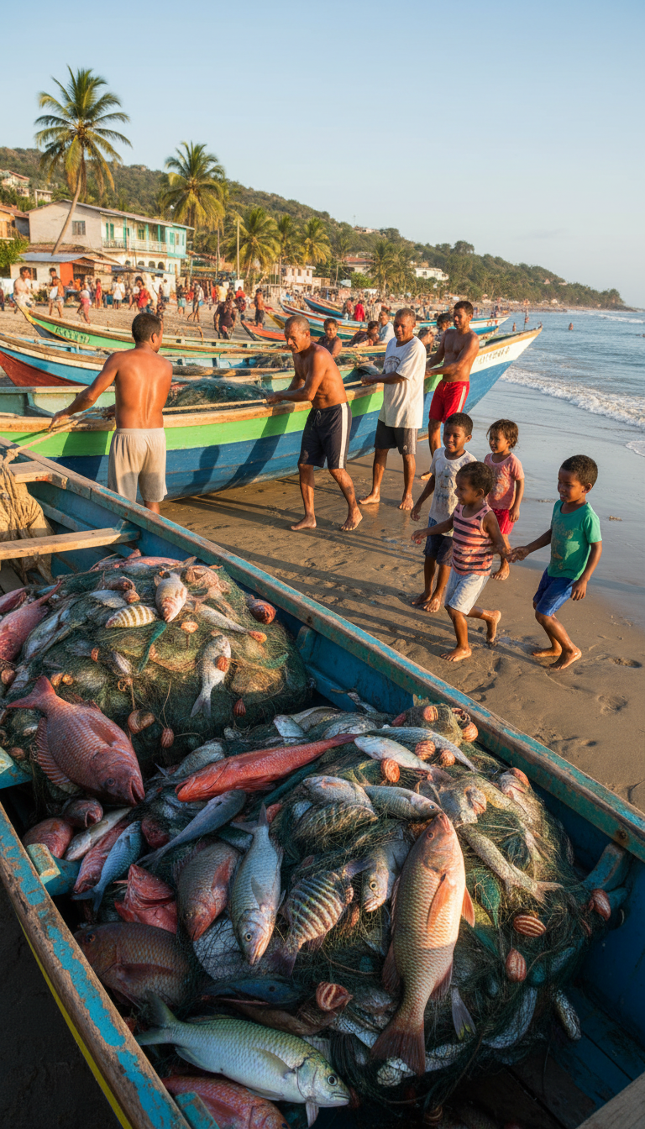
Dominican fishermen bringing in the daily catch, teaching refugees about coastal life.

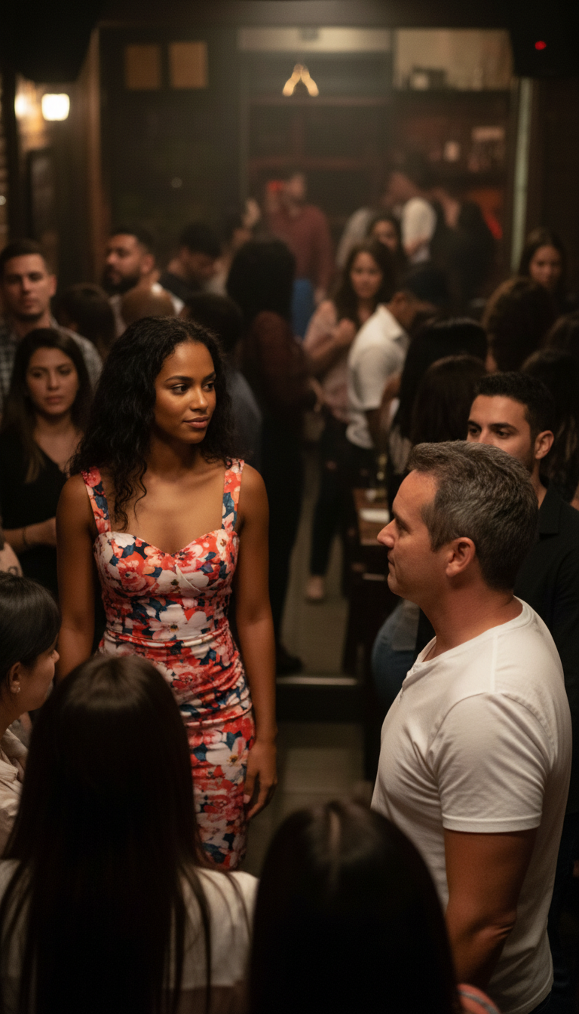
Sosúa beach - where two worlds would come together to build a new future.

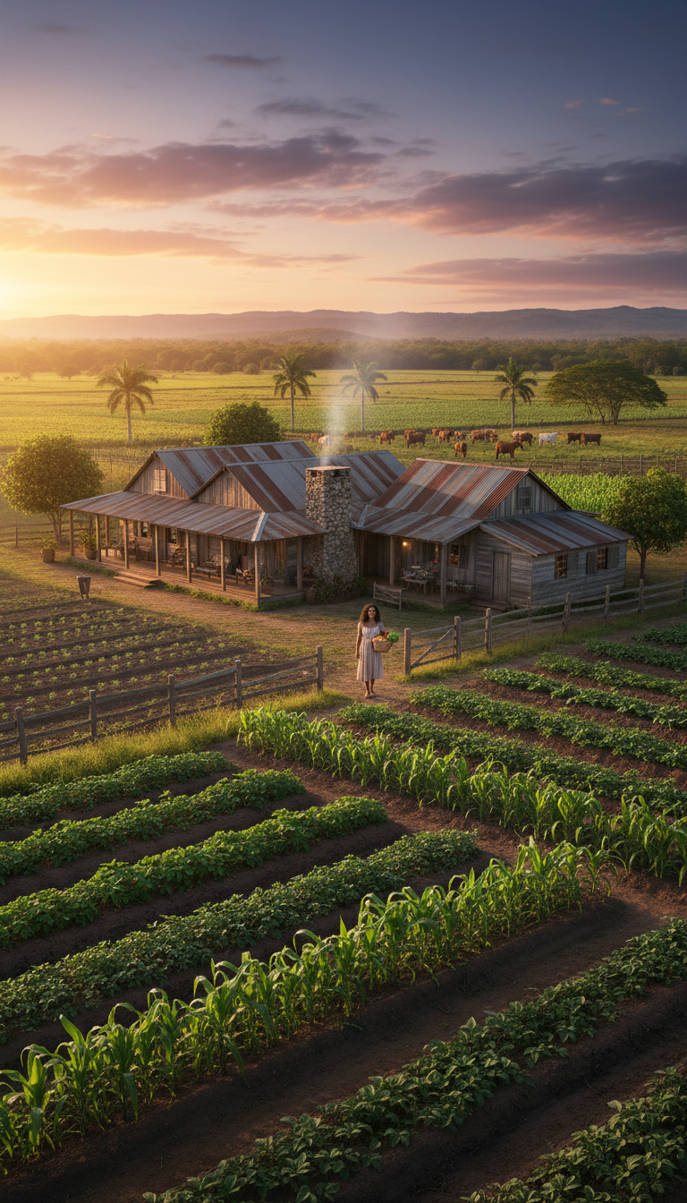
"Farmin' Ain't Easy" - The farm at sunrise. Thriving fields and cattle, fruit of Josef and María's labor.

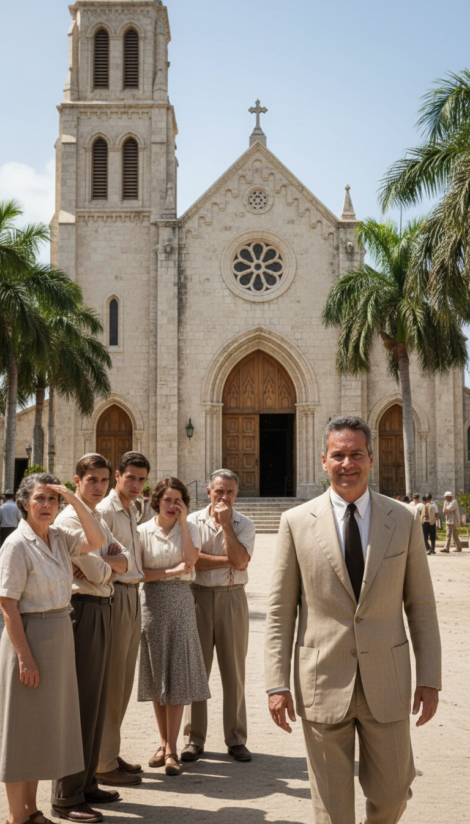
The Catholic church in Sosúa, surrounded by palm trees.

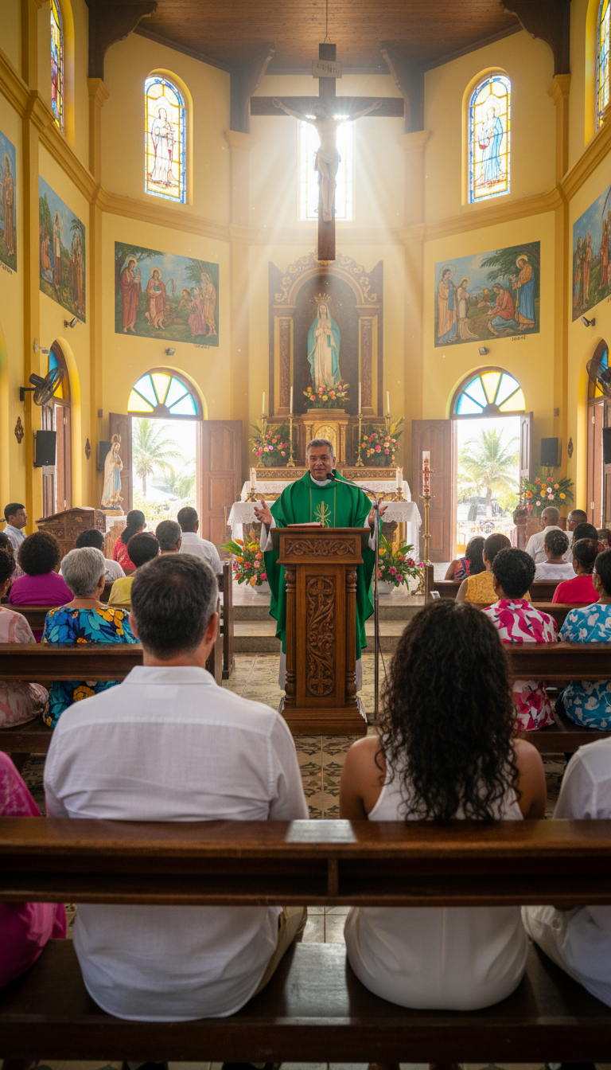
"Sunday in Sosúa" - Inside the church. Padre Luis leading mass, refugees and Dominicans worshiping together.

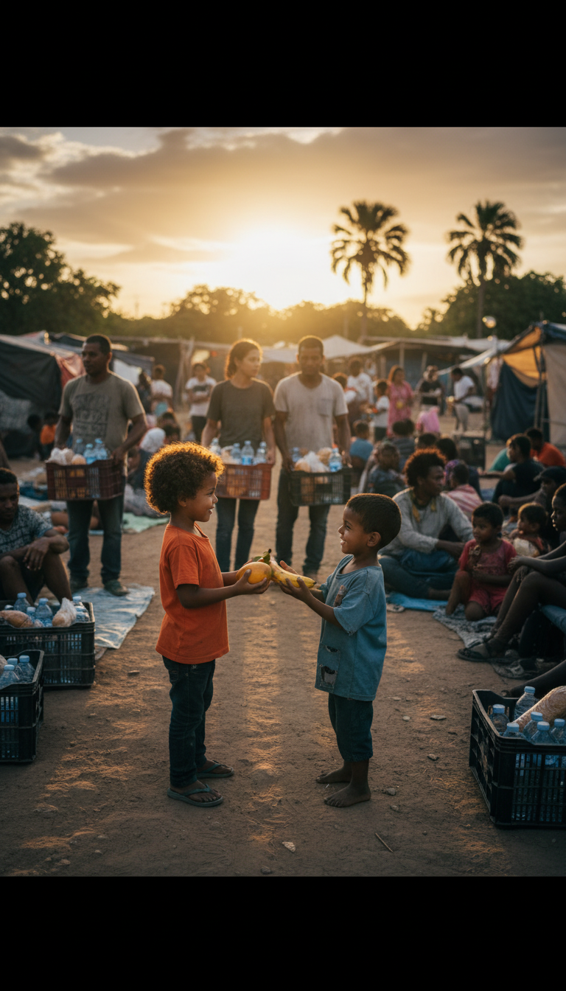
"Rhythms of Sosúa" - Community gathering at sunset, sharing food and welcome.

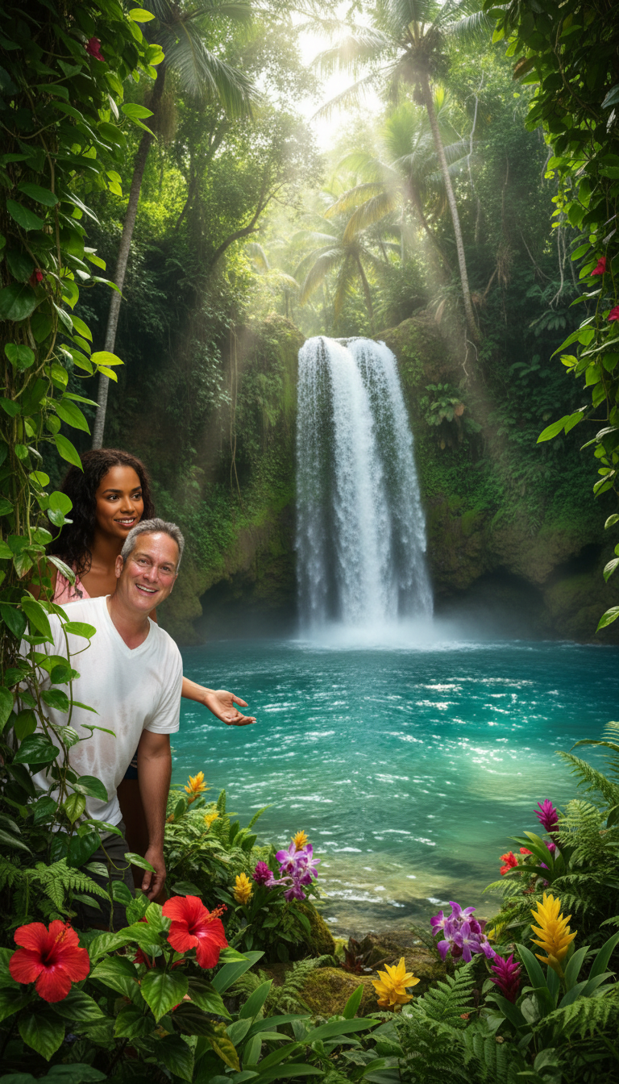
"I Know What You Mean" - Josef and María at the secret waterfall - where they fell in love.

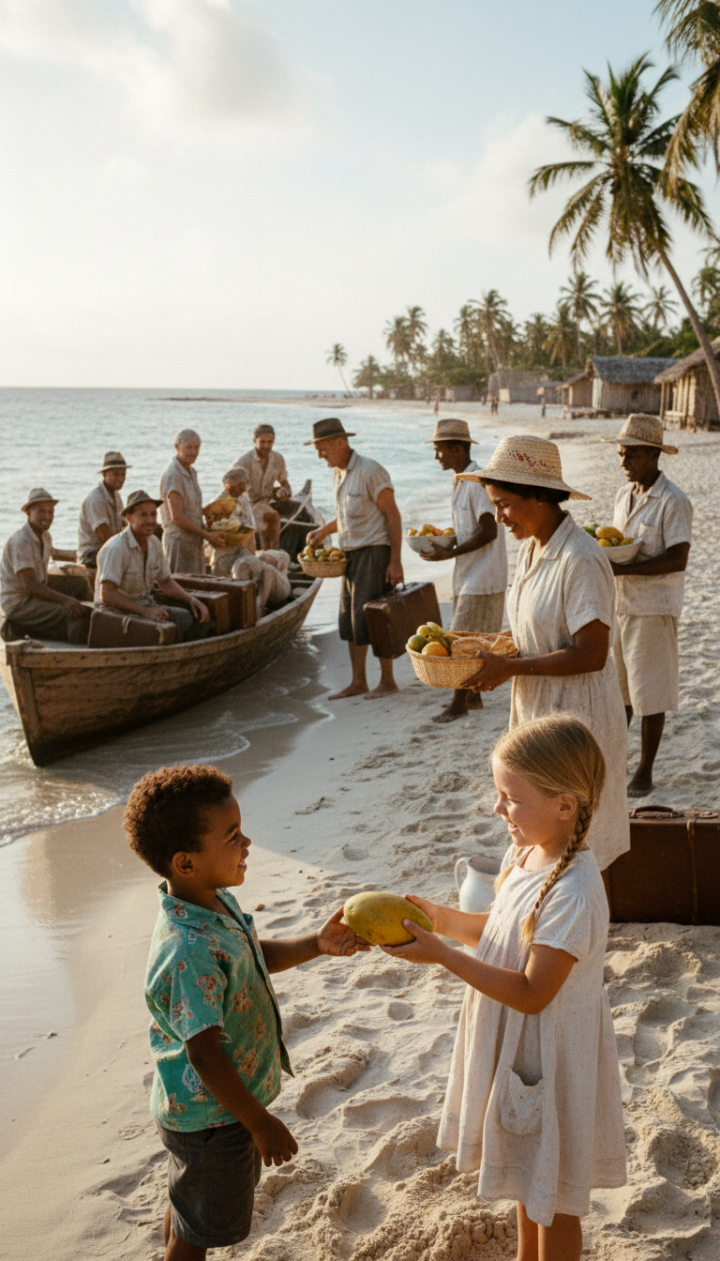
"Pan de Coco Paradise" - The next generation. Dominican and refugee children sharing coconuts on the beach.

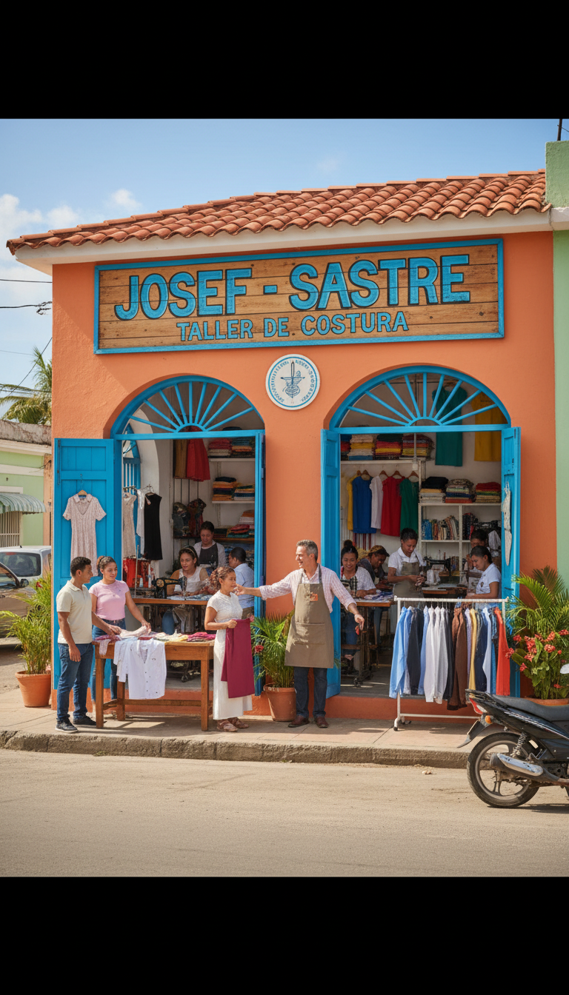
"Josef, The Tailor of Sosúa" - Josef's thriving shop in vibrant Caribbean colors.

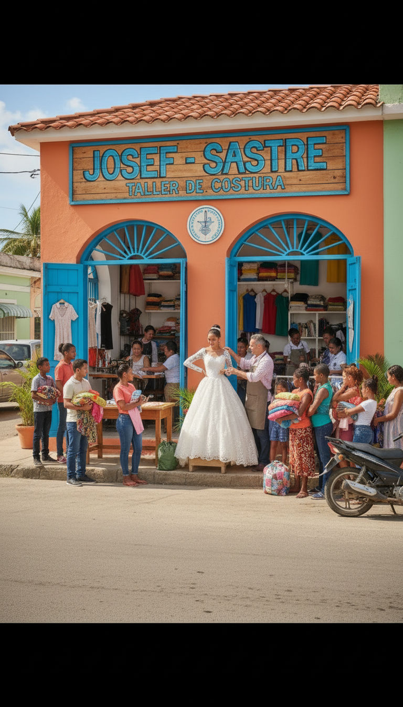
"Thread by Thread" - Josef fitting a bride. The tailor shop as the heart of community celebrations.

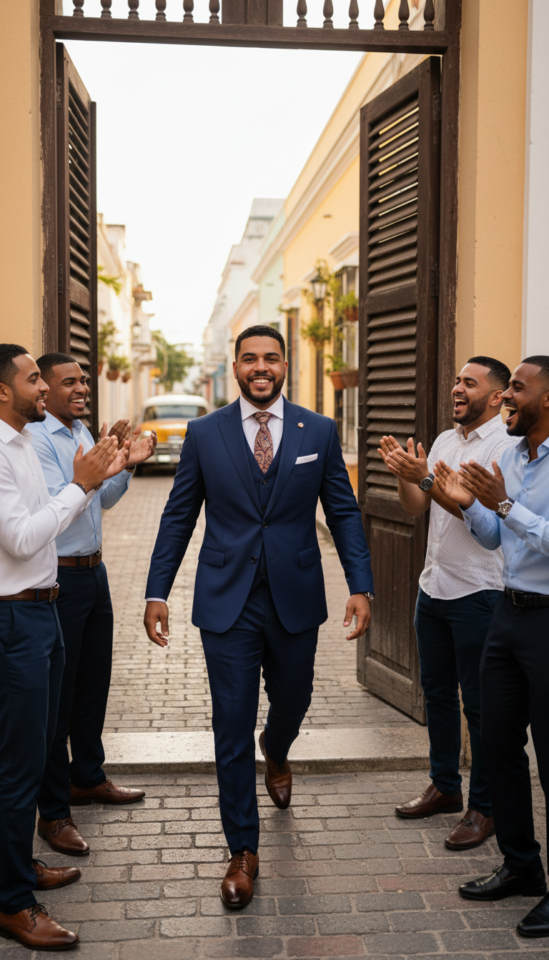
Dominican men in Josef's fine suits - proud, confident, celebrating his craftsmanship.

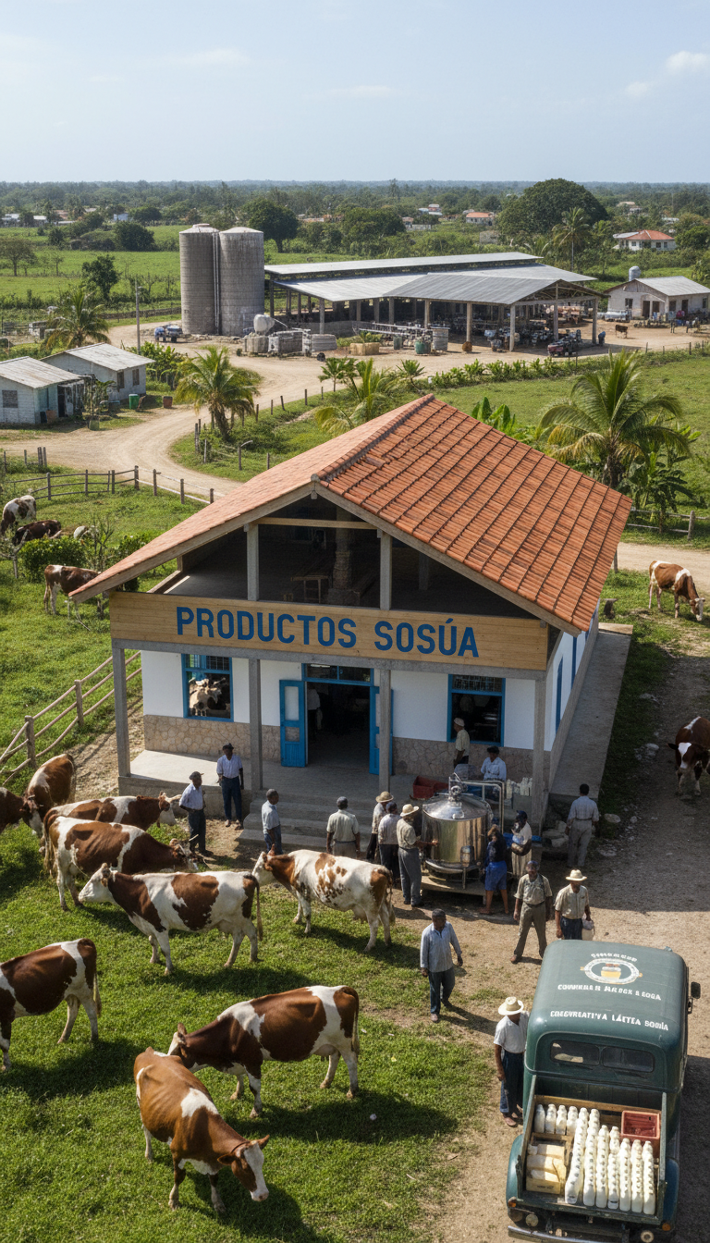
Productos Sosúa - the dairy cooperative built by refugees and Dominicans, still operating today.

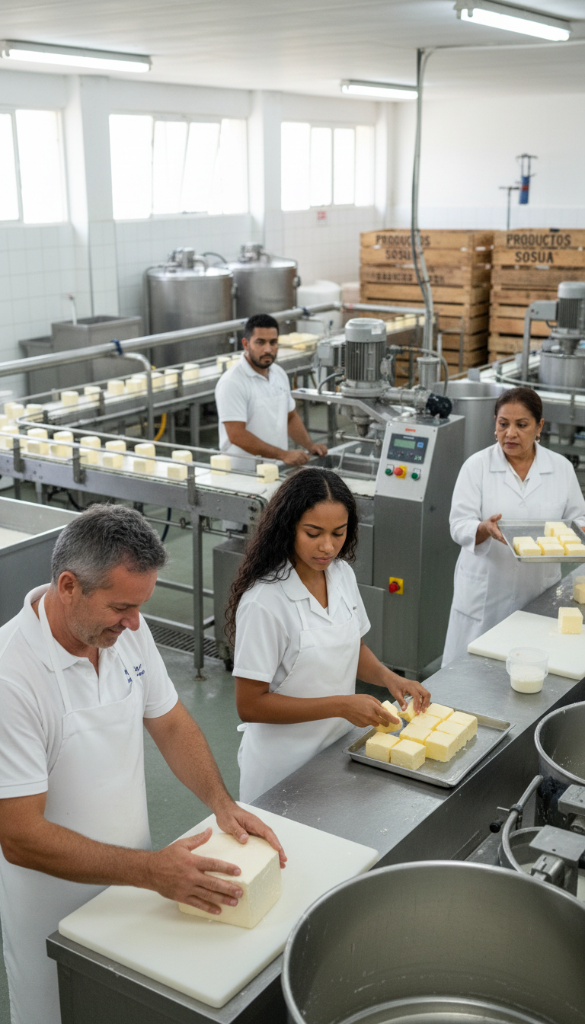
Inside Productos Sosúa - workers making cheese, carrying on the legacy.

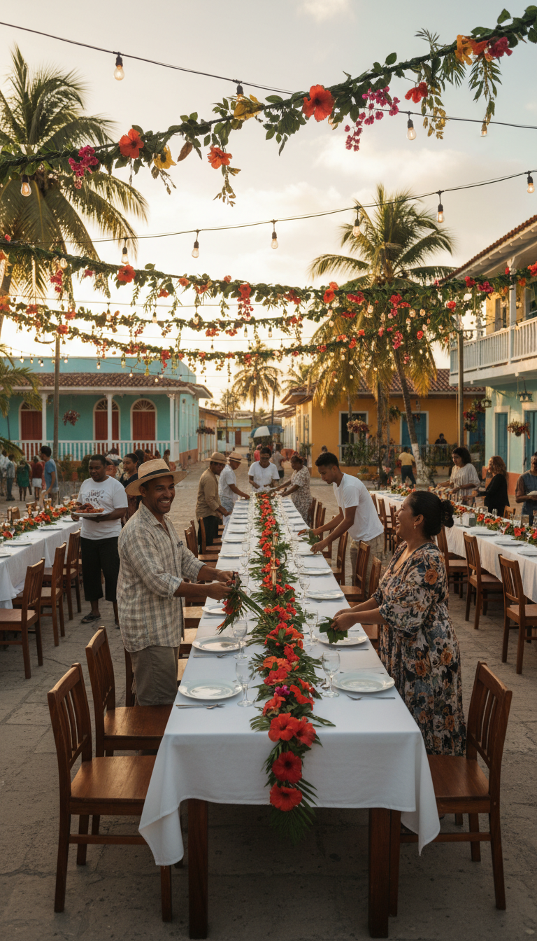
"Sosúa Sunset Feast" - Refugees and Dominicans celebrating together in gratitude.

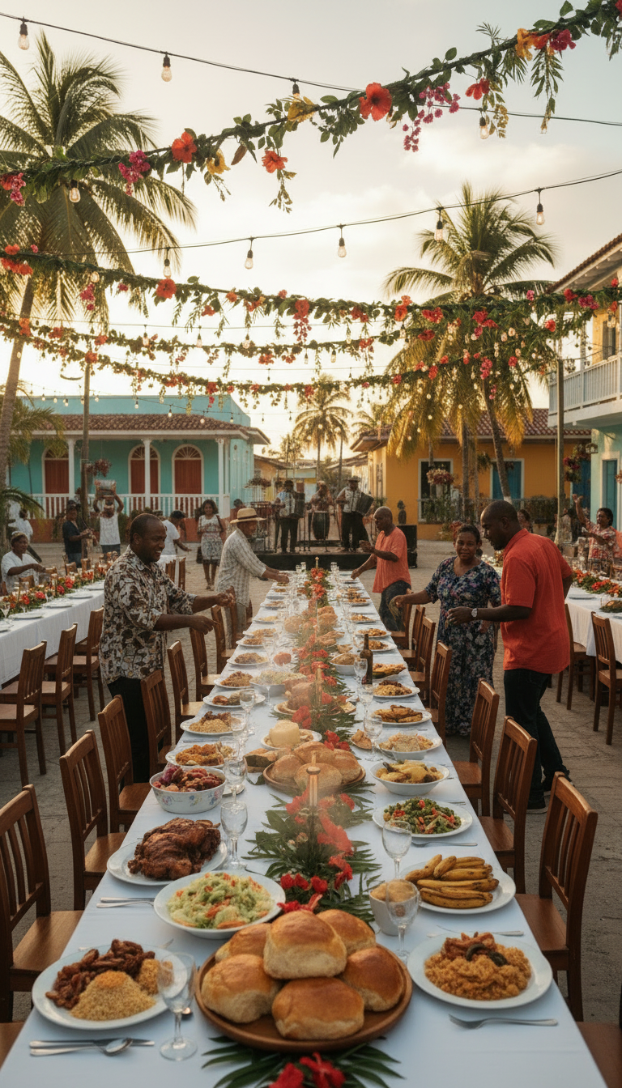
The feast tables overflowing with abundance - Dominican and European foods celebrating together.

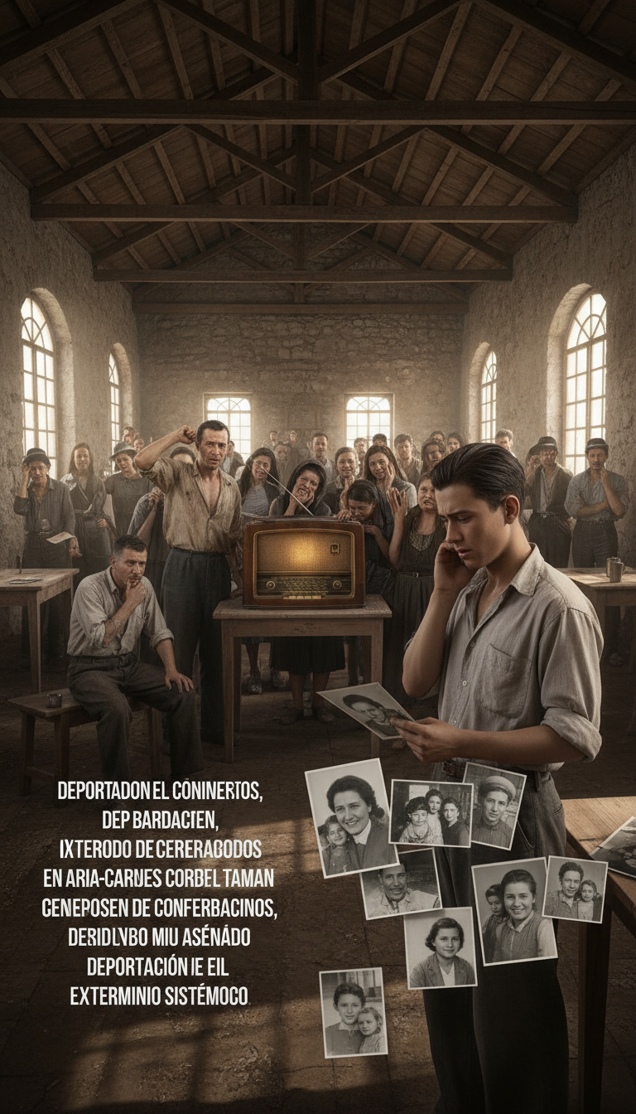
"Survivor's Prayer" - The refugee community hearing devastating news from Europe - learning of the Holocaust.

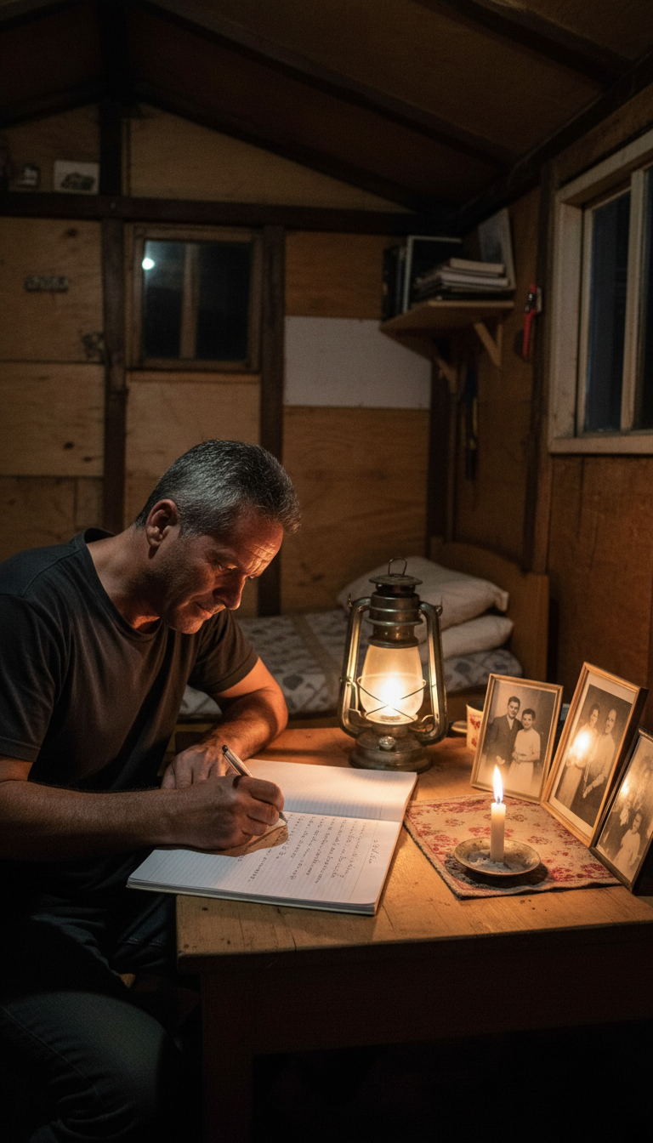
Josef writing by lamplight, remembering those left behind with candles and photographs.

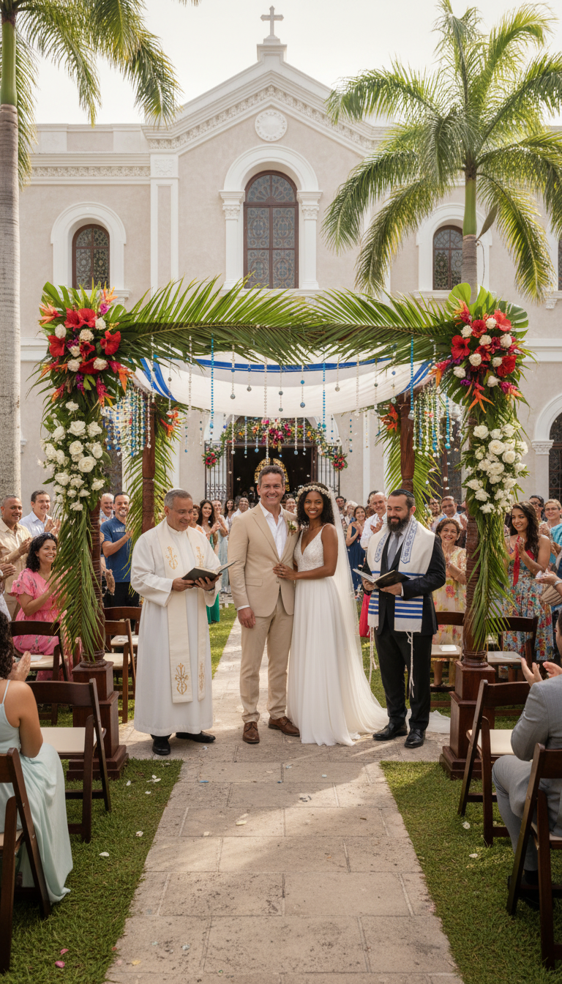
Josef and María's wedding - blessed by both Rabbi and Padre Luis. Two faiths, one love.

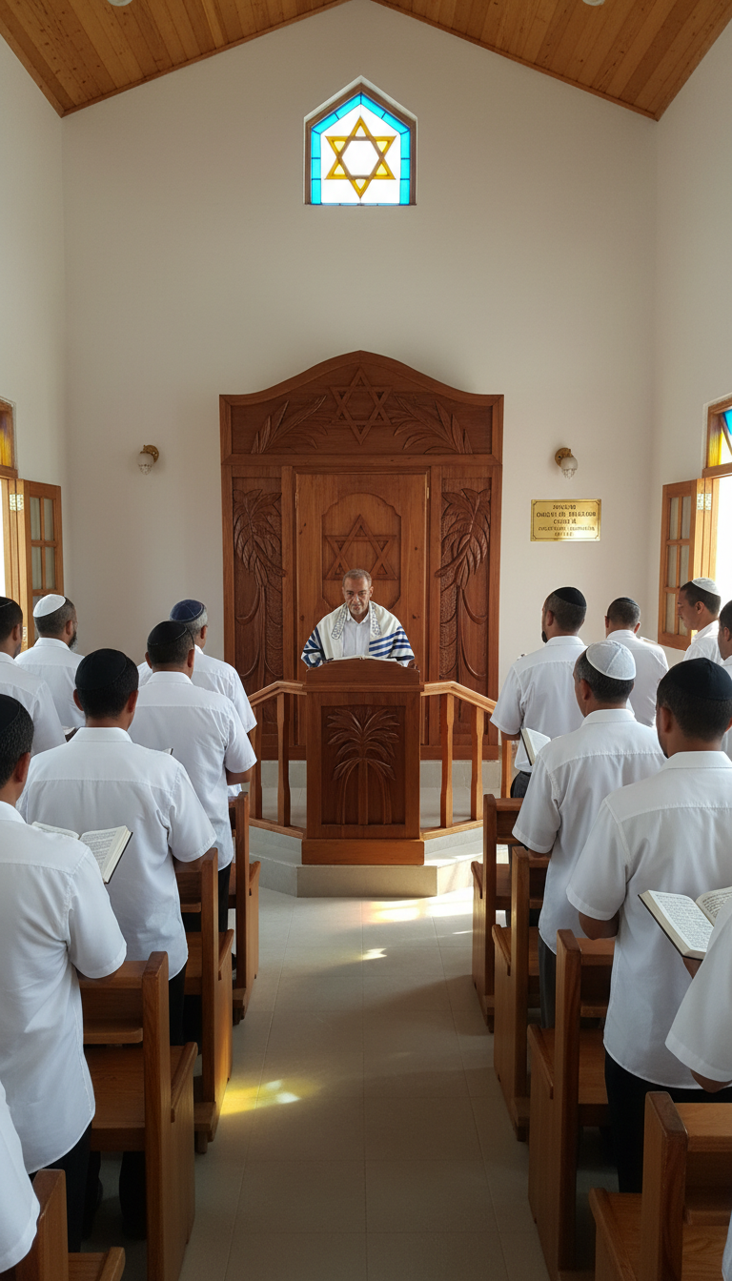
Inside the synagogue - the Star of David window. Jewish community preserving their faith.

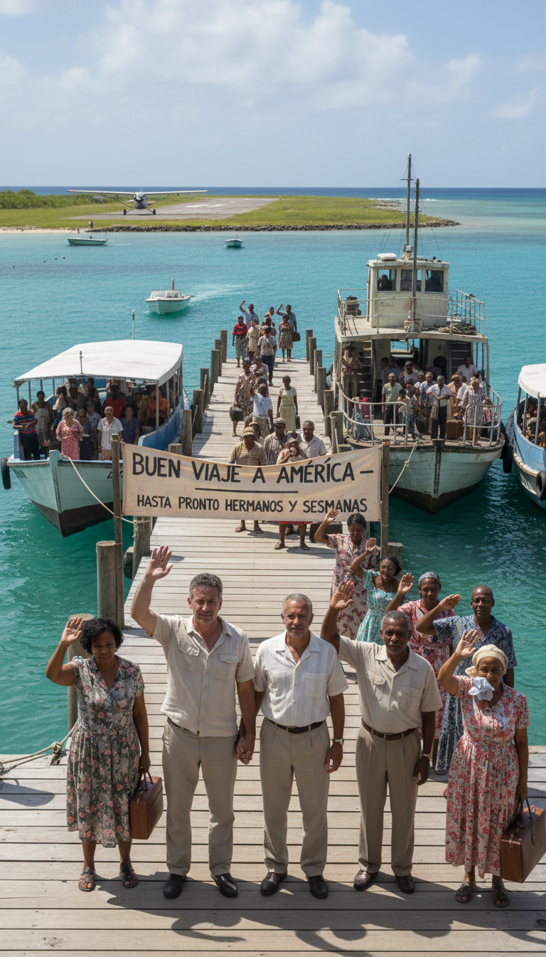
"A New Horizon" - Refugees arriving by boat. 'Buen Viaje a America - Hasta Pronto Hermanos y Sesmanas.'

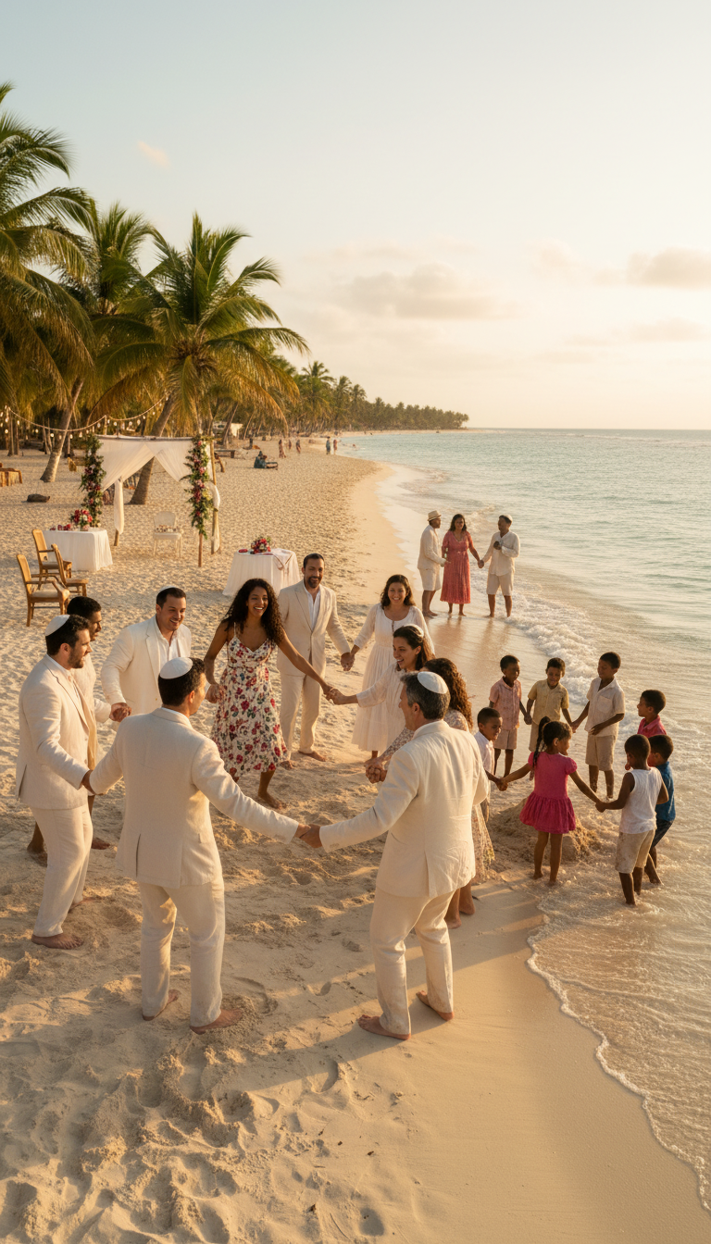
"Sosúa, So Beautiful" - The finale. Entire community in a circle on the beach, celebrating unity and love.

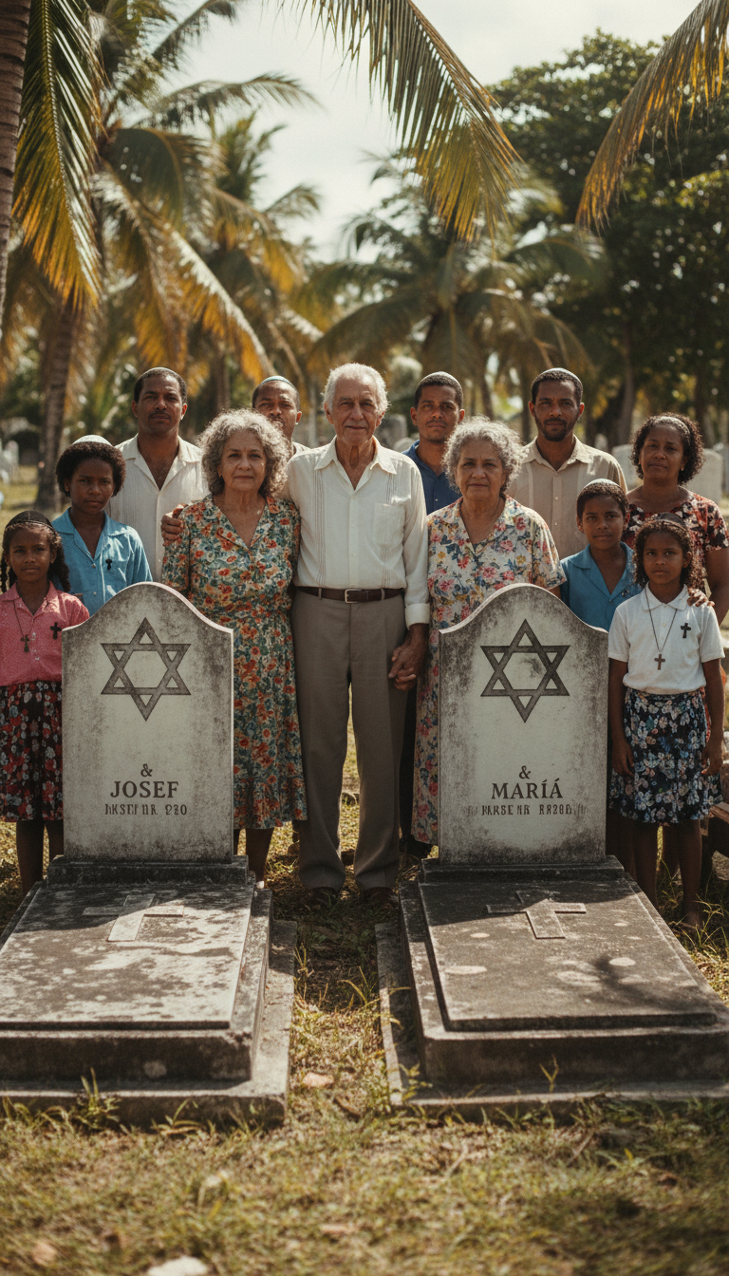
Josef and María's descendants at their graves - a family of Jewish-Dominican heritage.

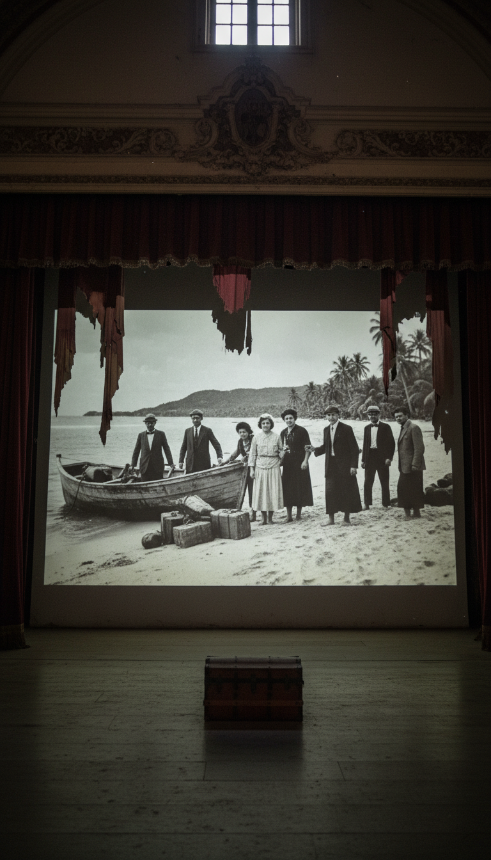
Historical photo projected in theater - bridging past and present, memory and legacy.

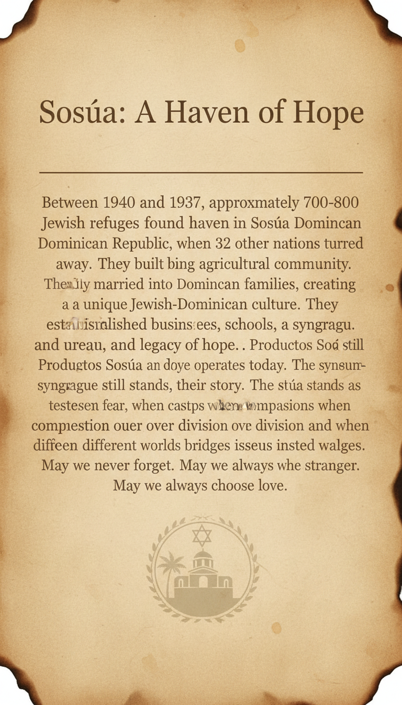
Historical plaque: 'Sosúa - A Haven of Hope.' May we never forget. May we always welcome the stranger.

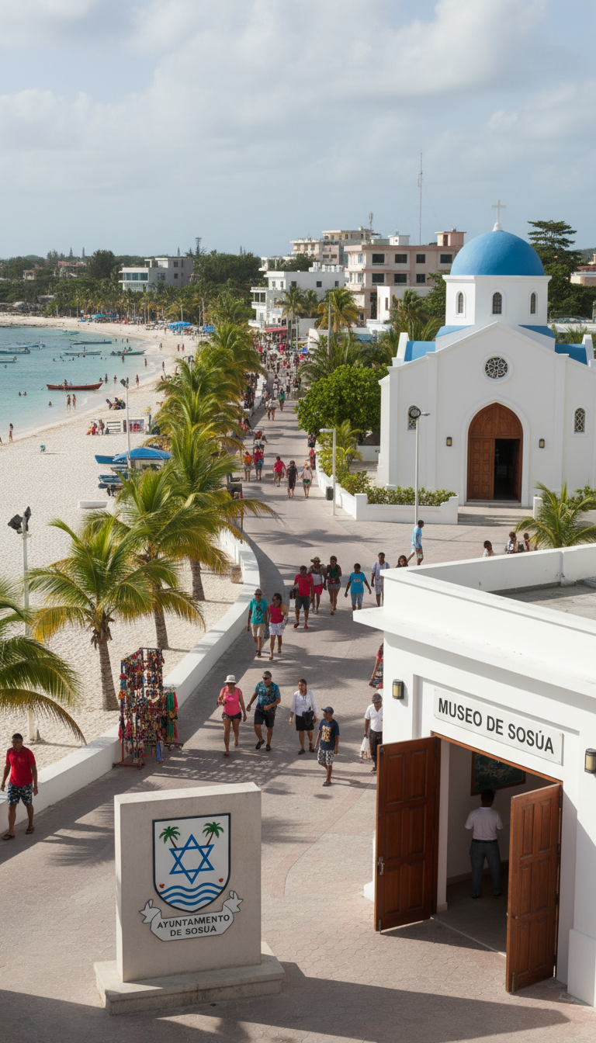
Sosúa today - Museo de Sosúa and the city seal bearing the Star of David and palm trees.

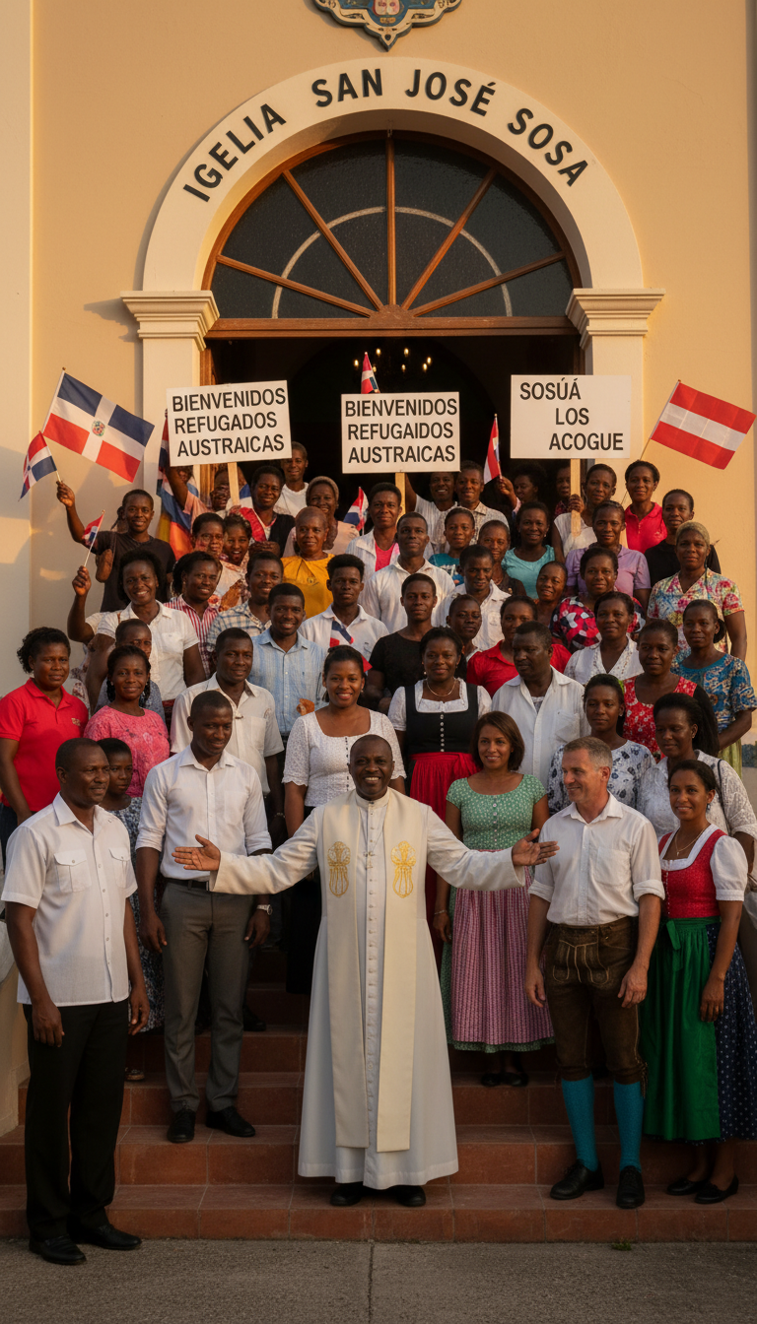
Igelia San José Sosa - the modern community celebrating the legacy with flags and welcome signs.

SOSÚA
When the world said NO, one island said YES.
700-800 Jewish refugees found safety in Sosúa, Dominican Republic. They built farms, businesses, families. They married into Dominican families, creating a unique Jewish-Dominican culture that endures today.
Productos Sosúa still operates. The synagogue stands as a museum. The city seal bears both Star of David and palm trees. The story lives on.
May we never forget. May we always welcome the stranger. May we always choose love.

